Notes 1-13

Switch Networks

* 2 kinds
  + Packet Switched (postal service model)
  + Circuit Switched (phone)

Packet Switched:

* Connectionless, packet oriented, datagram network
  + Hop by hop just like a postal service model
    - Means that the network moves (forwards) data from place to place by forwarding towards its destination (this is called ‘hop by hop’)
  + Data carries the destination address
  + Overhead associated with reading and processing the address
  + The setup overhead is low or non-existent
    - When you want to send a message with this model, there isn’t anything you have to do in advance to set it up (you don’t have to call postal service and see if there is space on the truck and all that)
* This is best for short lived interactions between many nodes
* This would not be the best model with a long-lived communication with one node.
* Examples: Opening a website, mail, clients accessing a server / many servers
* People who like this are called net-heads

Circuit Switched

* Connection oriented
* Complete end-to-end connection (this will happen at the beginning of the communication before any data is sent). The path is determined by the destination address.
* Overhead associated with connection setup (creating a new connection) and teardown (done with the connection)
* Forwarding overhead is low or non-existent
* Examples: Streaming media,
* People who like this are called bell-heads

**BE ABLE TO EXPLAIN THESE FROM SCRATCH!! Meow**

Point to Point Network:

* Simplex connection: We can only send messages in one direction. Sender and receiver that never change roles. (sensor sending temp to cpu).
* Half-Duplex: Like simplex in the sense that there is a sender that is only sending and a receiver that’s only receiving, but they can switch roles. (cpu asking for the temp form the sensor). Walkie-Talkies.
* Full-Duplex: We can be both a sender and a receiver at the same time.

Ring Network:

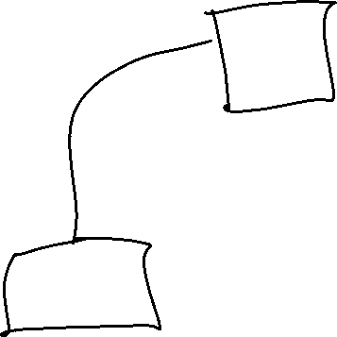

Bus Network:



Star Network:

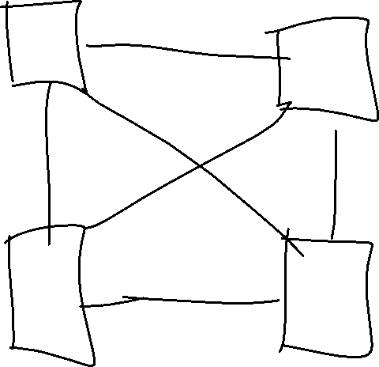

* Considered full-mesh when fully connected

Hub and Spoke Network:

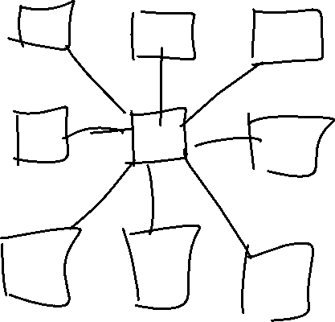

Switched Network:

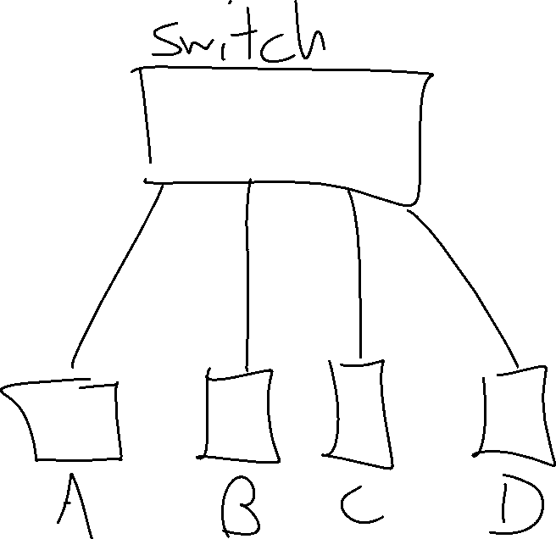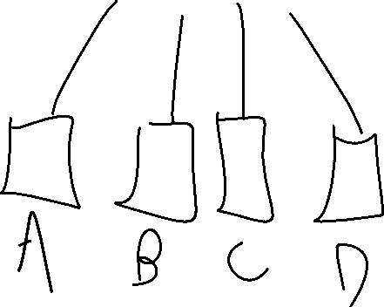

Network-of-Networks is called an Internetwork a.k.a Internet

* Internet with capital I is what we all know
* Internet with i is an arbitrary network

Networks need to support 3 types of communication:

* Point-to-point:
* Broadcast traffic: Send something to everyone on the network
* Multicast: One node wants to talk to many nodes but not all of them

PAN- Personal Area Network

LAN- Local Area Network

WAN- Metropolitan / Wide

Network (def): two or more nodes connected by a link, two or more networks connected by one or more links, two or more internetworks connected by one or more links